Joseph Dickerson

PHC6790

Lab 1

09/21/2025

1. The sample size required for the study to have 90% power when the true odds ratio is 4 is 102. With two controls per case, this would mean 68 controls and 34 cases.

Balanced:

|  |  |
| --- | --- |
| True Odds Ratio | Sample Size Per Group (total) |
| 2 | 188 (376) |
| 3 | 73 (146) |
| 4 | 46 (92) |

Unbalanced: two controls per case

|  |  |
| --- | --- |
| True Odds Ratio | Sample Size Per Group: control/case (total) |
| 2 | 280/140 (420) |
| 3 | 108/54 (162) |
| 4 | 68/34 (102) |

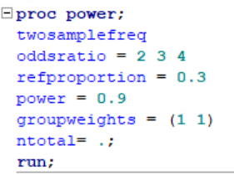 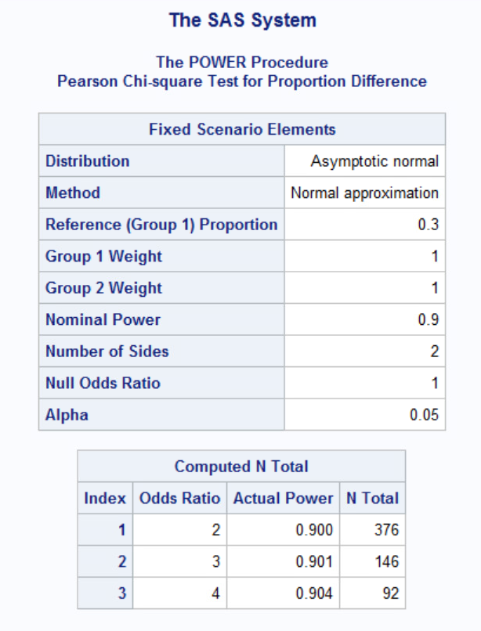

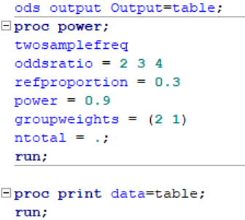 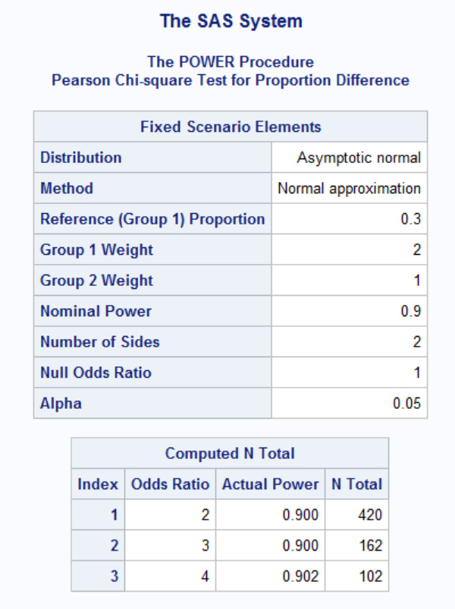

2a.

The overall sample size needed to detect an increased odds of defect (corresponding to OR = 2.5) is 194. With an equal sample size in each group, this means 97 per group if the study intends to have a power of 85% with significance level of alpha = 0.05.

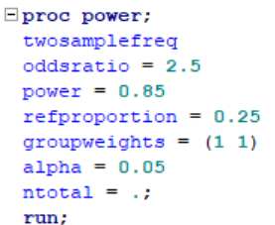 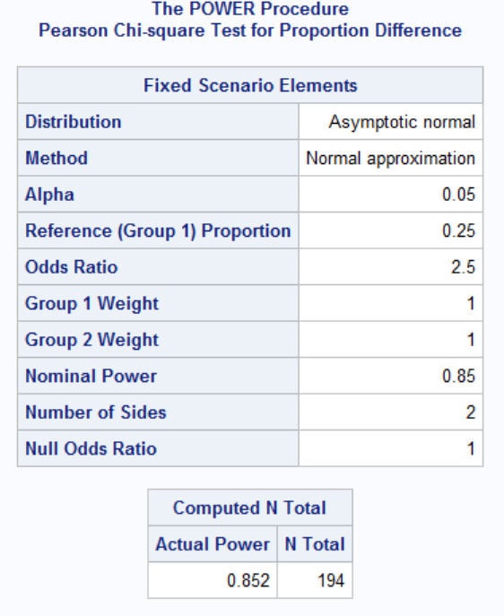

2b.

Changing the weight so that there are 3 controls to each case will result in an overall sample size of 252. 252 divided into quarters is 63. This means there will be 63 cases and 189 controls to obtain the three controls per case desired at the sample 85% power and 25% exposure rate as the previous example.

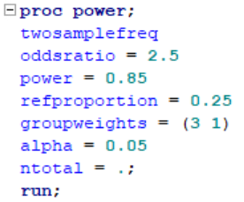 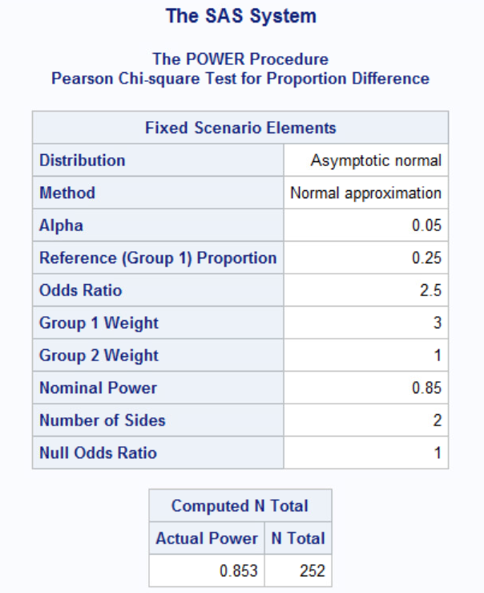

2c.

Using the sample size of 194 from part a., it appears from the figure that an odds ratio of 2.75 corresponds to a power of 90%.

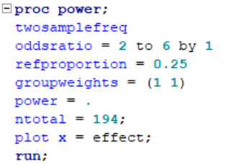 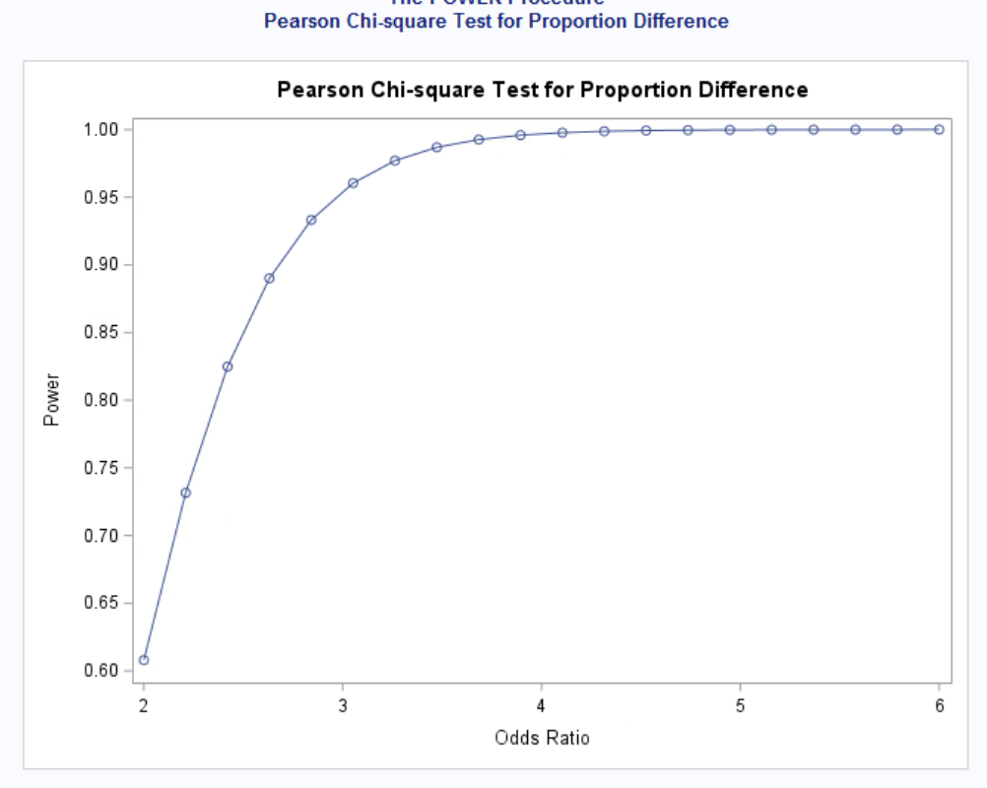

3a.

A chi-square test of association will be performed because each count in the 2x2 table is greater than 5. We will test for independence:

Hsub0, or the null hypothesis, is true if the odds ratio equals 1.

Hsub1 is true if the odds ratio does not equal 1. This would indicate that *maternal hormones* and *heart defect* are not independent.

3b.

The chi-squared value in this scenario is 5.5521 with a p-value of 0.0185. This indicates the null hypothesis is rejected at significance 0.05, or 5%, which means *maternal hormones* and *heart defect* are not independent. In plain terms, there may be a relationship between heart defects and exposure to hormones.

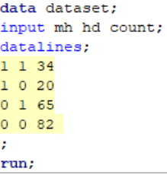 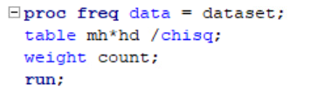

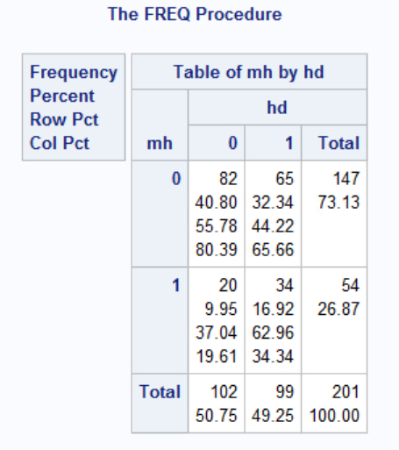 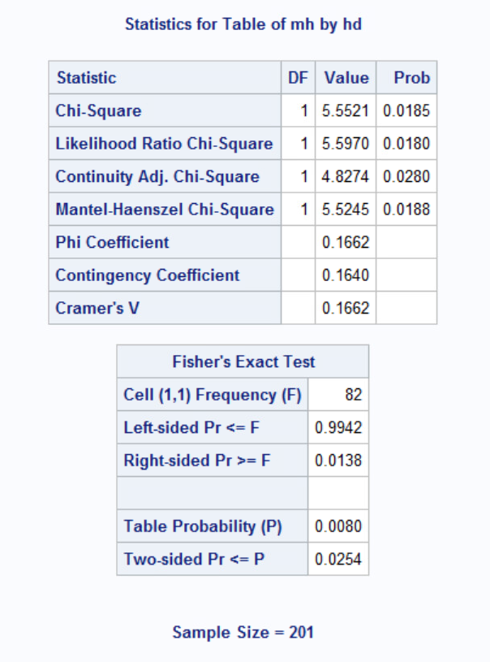

3c.

The odds ratio is calculated: (34 * 82) / (20 * 65) = **2.15**. This is confirmed in SAS using the table of odds ratio and relative risks. Within the 95% confidence limits, the odds ratio lies between 1.1296 and 4.0717.

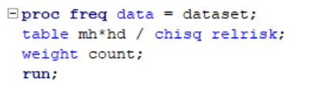 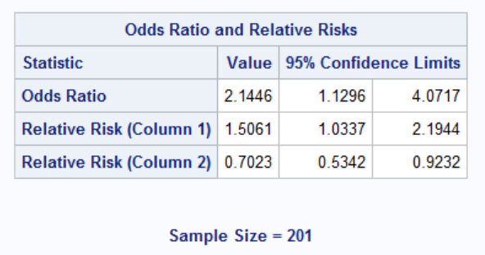

3d.

The confidence interval does agree with the hypothesis test findings because it does not contain 1 in its interval.

3e.

In Part 2 we assumed an odds ratio of 2.5 but had an odds ratio of 2.15 observed. This effect size is not far from the assumption made. In the figure, the odds ratio appeared to be 2.75, which is a decent bit further than the observed. The reference proportion used was 0.25, though the observed was 20/102, which equals 0.196. This is a bit off from the assumption of 0.25. All in all, the study is not too far off from the planned assumptions, though they could be a bit closer.

4a.

Because the researchers believe the alcohol group will have a 73% higher risk than the no alcohol group, the relative risk in this example is 1.73.

4b.

With an assumption of 90% power to test the effect at a 0.05 significance level with equally weighted groups, 26,764 would be an appropriate sample size given the setup and goal of the study. This also uses the assumed relative risk of 1.73 and estimated rate of 0.004 from part 4a.

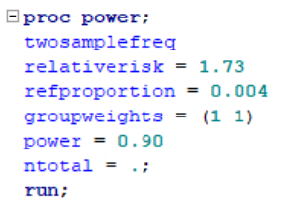 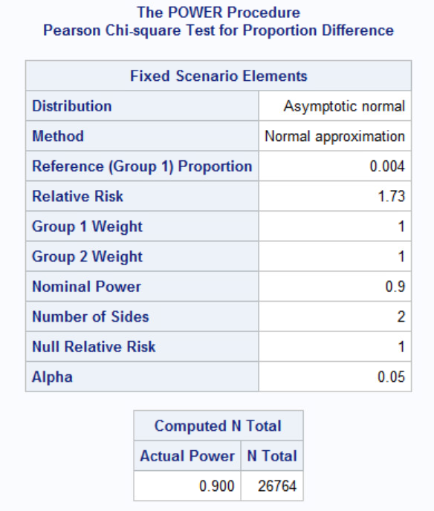

4c.

If an estimated 5% of enrollees are expected to drop out, the new total subjects would be:

26764 / 0.95 = 28172.63. Rounded up this equals 28173, but if the researchers wished to keep have an equal weight at the start it could be rounded down to 28172 subjects.